***RoBiOtics Inc.***

**Executive Summary**

**Who we are:**

RoBiOtics Inc. is a startup company that focuses on blending biology and robotics to solve problems in the healthcare industry. We are a for profit company that is currently focused on developing an app called MalPal.

**The problem we tackle:**

Many healthcare patients suffer from the problem of malnutrition. Hospital patients in particular experience malnutrition at shockingly high levels. Between 20% - 50% of hospital patients experience malnutrition during a stay. Malnutrition can lead to longer hospital visits, increased risk of infection, and increased morbidity and mortality.

**What solutions we provide**:

Our solution to this problem is our novel AI driven image detection system called MalPal. MalPal utilizes image detection to identify how much food a person has consumed during a meal. MalPal detects the type of food on a plate, then detects approximately how much of each food type has been eaten. If MalPal detects that at least 50% of a meal has not been consumed for 3 days in a row, then an alert is sent to help prevent malnutrition in a patient.

**Our market and size:**

Our total available market is the total hospital information system market (USD 115 billion in 2022). Our serviceable available market is the AI in healthcare market (USD 15.4 billion in 2022) and we have about 3% of market share.

**What the competition fails to do:**

Our competition fails to have a robust, automated system that can help prevent malnutrition in a person. Currently, traditional ways of tracking malnutrition in patients include surveys and human managed screening tools. MalPal is the only system of its kind in how it helps prevent malnutrition.

**Our needs:**

Currently, our startup is looking for $300,000 to ensure that we can hit our timeline goals. We offer a 20% stake in our company.

**Our Team:**

RoBiOtics is composed of three computational scientists working to develop an AI that detects malnutrition in healthcare settings. Our CEO is Kenneth Cochran, our CTO is Omar Shakhtour, and our

CFO is Joe Siapno.

**Customer Discovery Plan**:

We have already reached out to customers working in the healthcare industry and , and we used their thoughts to improve our understanding of the target customers for our product. Our original plan was to just ask other people working in the healthcare industry, such as doctors or nursing home staff, for their opinions on the product. However, we have decided to also try and expand into a consumer market with a general health app – utilizing the ai detection software built for MalPal. We would then reach out to people that use healthcare apps and ask them if they would be interested in an app that can track nutritional intake just by using their phone’s camera.

**Agenda**

Board Meeting 3

April 27th, 2023

**HOST:**  Kenneth Cochran – CEO

**ATTENDEES:** Joe Siapno – CFO, Omar Shakhtour- CTO, our investors

**Time (PDT) Topic Presenter**

2:30 - 2:35 Welcome CEO

2:35 - 2:40 Opening statements CEO

2:40- 2:43 Approval of Agenda CEO

2:43- 3:00 Presentation CEO/CTO/CFO

3:00 - 3:25 Round Table Discussion All

3:25 - 3:30 Adjournment CEO

**Agenda**

Board Meeting 1

March 14th, 2023

**Business summary**

The problem:

Malnutrition affects between 20-50% of at-risk hospital patients [1]. Furthermore, only around 8% of malnutrition is diagnosed in patients [2]. Detecting malnutrition is not a top priority for healthcare professionals. Healthcare professionals focus on the sickness for which the patient was admitted, and this can often mean that something such as malnutrition goes undetected.

Company value proposition:

Helping prevent hunger, one byte at a time.

Who you are (experience in the problem):

RoBiOtics Inc. is a team of three computational scientists working to develop an AI that detects malnutrition in healthcare settings.

The Chief Executive Officer is Kenneth Cochran

The Chief Technical Officer is Omar Shakhtour

The Chief Financial Officer is Joe Siapno

Product/service:

MalPal is an artificial intelligence-powered software that detects malnutrition in hospital patients. Using AI image detection, MalPal analyzes a patient’s food intake and calculates nutritional composition using its comprehensive database of nutritional foods. Money is made through the selling of the MalPal software, and additional profit is generated from the selling of individual MalPal cameras, which connect to the MalPal software.

**Financial summary**

Customer discovery data:

We have interviewed ten people so far, whose occupations ranged from those in the healthcare industry to people working in desk jobs. The problems we asked were “Do you or anyone you work with often experience malnutrition?” and “If so, is it hard to visually detect it?”. We asked three people that worked in the healthcare industry, and they said yes to both questions, however, one person said that their job doesn’t deal with treating malnutrition, thus they don’t need to worry about detecting it. Five people, not working in the healthcare industry, said that they were not sure to the first question, and they said yes to the second question. Two people said no to the first question, so they were not asked the second question. Based on their statements, we improved our understanding of MalPal’s target customers.

Market size (TAM/SAM/SOM):

The Total Available Market is the total hospital information system market (USD 115 billion in 2022). The Serviceable Available Market is the AI in healthcare market (USD 15.4 billion in 2022). The Serviceable Obtainable Market is about USD 450 million, which is based on the total number of nursing homes and hospitals in the United States (about 30,000).

Profits and/or funding to date:

We have not gathered any profits so far, considering that we have not yet deployed a minimum viable product for customers. However, we have used $1,000 of our own money to develop our software, create prototype cameras, and launch a website.

Wins to date (what you have done thus far):

* We have developed most of our software, and we have created a comprehensive food database based on sample hospitals’ meal plans.
* We have started our customer discovery plan, which currently involves asking questions to people working in the healthcare industry and in regular desk jobs.
* We have created a website for MalPal that shows how the product works and the main purpose of the product.

Hurdles to overcome (things in the way):

* We still need to acquire additional funding for our product and related services, such as a server.
* We are still creating the minimum viable product to show that the product is saleable, and we are developing our market strategy for said product.
* The website for MalPal is not completely done yet, in that it lacks information about the company, ways to contact us, and other needed features.

**Milestones**

Financial:

With $1,000 coming out of our own pocket, we have already developed most of the software for MalPal, and we have paid camera manufacturers to make prototype cameras. We are in the process of talking to more angel investors and venture capitalists for further funding to increase the level of production of cameras and improve our software and hardware.

Product/Tech development:

MalPal started off as an idea to deal with the widespread issue of malnutrition in hospitals. It originally started off as a weight-based scale that would weigh food and enter it into the software database. This idea then developed furthermore once the idea of AI was introduced. It was decided that using AI image-detection would be a much more effective method of detecting malnutrition. After developing the software and engineering the cameras, the MalPal team built a comprehensive food database that includes essential nutritional components one needs. This database continues to be built using data mining and machine learning. Furthermore, the MalPal team is currently developing a consumer mobile app wherein the advanced MalPal AI software can be used to analyze the food intake of users such that they can track their nutritional intake. This will be accomplished through users scanning food with their mobile device, and the MalPal AI will analyze the food, giving the user the nutritional summary of the food product based on MalPal’s comprehensive database.

Customers:

We have already reached out to ten people working in the healthcare industry and regular desk jobs, and we used their thoughts to improve our understanding of the target customers for our product. Our current plan is to ask more people working in the healthcare industry, such as doctors or nursing home staff, for their opinions on the product. We would then incorporate their ideas for further improving the vision of our product.

Regulatory:

As of right now, there are no regulations on AI usage in healthcare environments. The only regulation that we may run into is regarding patient privacy, but MalPal does not intentionally detect any features of patients. Furthermore, after uploading the nutritional data of the food into the database, MalPal automatically deletes the image from its server. Therefore, no patient information, other than nutritional data, is stored. Additionally, we are looking to obtain a trademark for our logo, and we are planning to make our underlying code a trade secret. Furthermore, we are researching copyright law regarding databases, and we have found that databases are copyrightable if they constitute an original work of authorship.

Paths toward your milestones:

In the past few months, we discussed our idea of a product that helps detect malnutrition in hospitals. After many iterations, we have settled on the idea of utilizing artificial intelligence to aid the profitability of our product. We then created a website to help showcase our product, and are now actively looking for partners and investors. Additionally, based on customer discovery feedback, we are looking into creating a consumer app that would help with detecting malnutrition and monitoring dietary intake.

In the next six months, we aim to discover new potential customers for MalPal by interviewing more people in the healthcare industry and other non-healthcare-related jobs. Also, during that time, we look to improve our hardware to a point where we can create a minimum viable product that can be used for beta testing in hospitals in the Charlotte area. Additionally, we will be looking for more angel investors and venture capitalists to help fund our business and the improvement of MalPal.

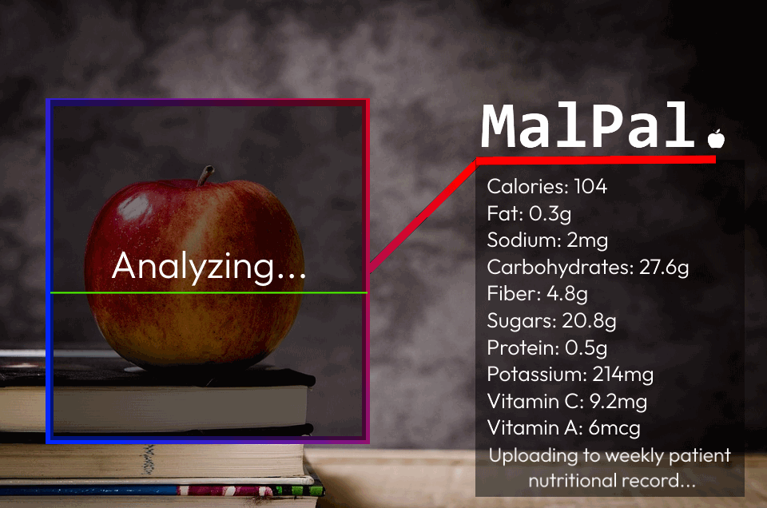

Sources:

[1] Barker LA, Gout BS, Crowe TC. Hospital malnutrition: Prevalence, identification, and impact on patients and the healthcare system. Int J Environ Res Public Health. 2011;8:514-527

[2] Barrett ML, Bailey MK, Owens PL, Brown MH. Non-maternal and Non-neonatal Inpatient Stays in the United States Involving Malnutrition, 2016. August 30, 2018